# DOMAIN PROJECT-1

**SYNOPSIS**

**ON**

## Topic Name: XXXXXXXXXXXXXX



|  |  |  |
| --- | --- | --- |
|  | **Submitted By** |  |
| xxxxxxxxx | xxxxxxxxx xxxxxxxxx | xxxxxxxxx |
| Rxxxxxxx | Rxxxxxxx  Rxxxxxxx  ***Under the guidance of***  **Mentor Name**  Assistant Professor- SG(**Designation**)  Department of Cybernetics | Rxxxxxxx |

**Department of Cybernetics**

**School of Computer Science**

# UNIVERSITY OF PETROLEUM AND ENERGY STUDIES

**Dehradun-248007**

**Aug-Nov, 20XX**

# Index

**Contents Page Number**

**Chapter 1: Abstract** 3

**Chapter 2: Introduction** 3

**Chapter 3: Problem Statement** 6

**Chapter 4: Literature** 8

**Chapter 5: Objectives** 8

**Chapter 6: Methodology** 10

**Chapter 7: System Requirement** 10

**Chapter 8: PERT Chart** 10

**Chapter 9: References** 10

# Chapter 1: Abstract

An abstract is a concise summary of an academic text (such as a journal article or dissertation). It serves two main purposes: To help potential readers determine the relevance of your paper for their own research[2].

Keywords: research, readers, journal

# Chapter 2: Introduction

The introduction serves multiple purposes. It presents the background to your study, introduces your topic and aims, and gives an overview of the research. A good introduction will provide a solid foundation and encourage readers to continue to the main parts of your research—the methods, results, and discussion[1].

# Chapter 3: Problem Statement

A problem statement is an explanation in research that describes the issue that needs study. What problem is the research attempting to address? Having a Problem Statement allows the reader to quickly understand the purpose and intent of the research.[3]

# Chapter 4: Literature

A literature review establishes familiarity with and understanding of current research in a particular field before carrying out a new investigation. Conducting a literature review should enable you to find out what research has already been done and identify what is unknown within your topic[4].

# Chapter 5: Objective

Research objectives describe what your research is trying to achieve and explain why you are pursuing it. They summarize the approach and purpose of your project and help to focus your research. Your objectives should appear in the introduction of your research paper, at the end of your problem statement.[5]

# Chapter 6: Methodology

Essentially, a methodology is a collection of methods, practices, processes, techniques, procedures, and rules. In project management, methodologies are specific, strict, and usually contain a series of steps and activities for each phase of the project's life cycle.

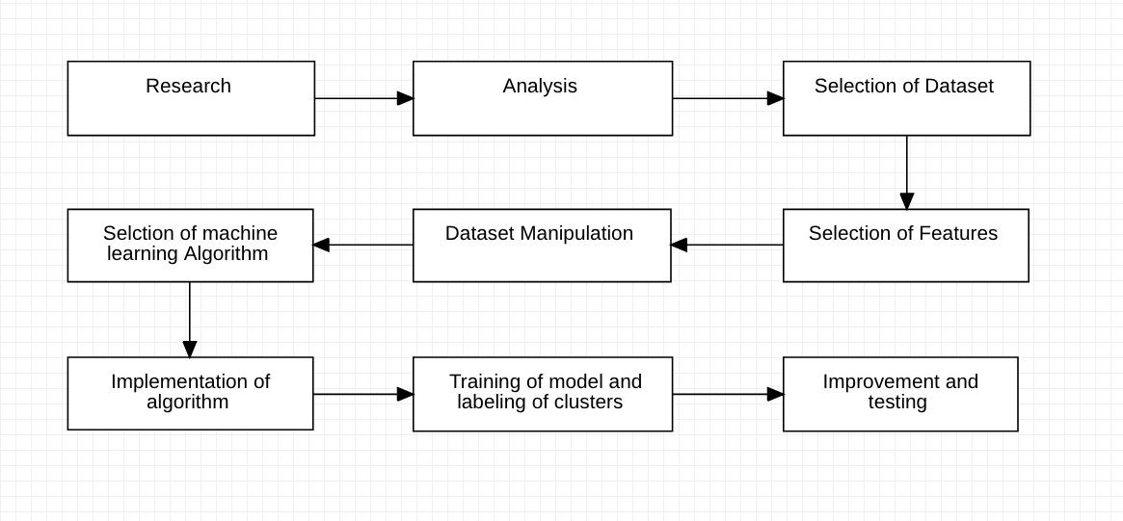

# Chapter 7: System Requirement

## 1. Software Requirements

Operating System : Windows 10/8/7 (32-bit or 64-bit)/ Linux

Software : Text Editor

Compiler : GCC

## 2. Hardware Requirements

Processor : Dual Core 2.7 GHz or better

RAM : 512 MB or higher

Disk Space : 512 MB

# Chapter 8: PERT Chart

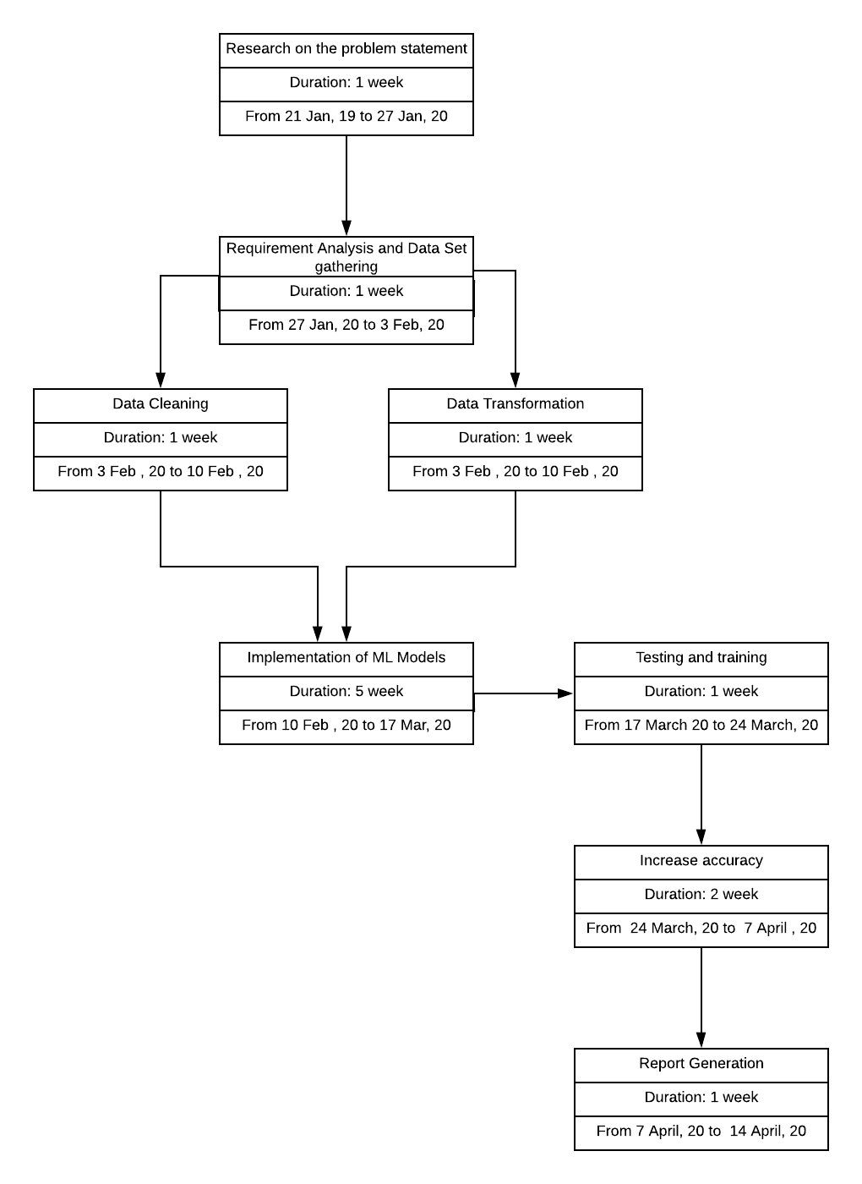

# Chapter 9: References

[1]<https://thinkscience.co.jp/en/articles/effective-introductions-to-original-research>

1. ​ <https://writing.wisc.edu/handbook/assignments/writing-an-abstract-for-your-research-paper/>
2. ​ <https://scientific-publishing.webshop.elsevier.com/research-process/what-problem-statement-examples/#:~:text=A%20problem%20statement%20is%20an,and%20intent%20of%20the%20research>.
3. <https://www.ed.ac.uk/institute-academic-development/study-hub/learning-resources/literature-review#:~:text=A%20literature%20review%20establishes%20familiarity,is%20unknown%20within%20your%20topic>.
4. <https://www.soas.ac.uk/cedep-demos/000_P506_RM_3736-Demo/unit1/page_26.htm>
5. Ayadi,​Moataz& Kamel, Mohamed S. &Karray, Fakhri. (2011). Survey on speech emotionrecognition: Features, classification schemes, and databases. Pattern Recognition. 44. 572-587.

10.1016/j.patcog.2010.09.020.

1. ​ [h](http://www.cs.yale.edu/homes/aspnes/classes/469/notes.pdf)​ ttps://imotions.com/blog/facial-action-coding-system/
2. Kerkeni,​ Leila &Serrestou, Youssef &Mbarki, Mohamed &Raoof, Kosai &Mahjoub,Mohamed. (2018). Speech Emotion Recognition: Methods and Cases Study. 175-182.

10.5220/0006611601750182.

1. ​ [h](https://dl.acm.org/doi/10.1145/2964284.2967276)​ [ttps://dl.acm.org/doi/10.1145/2964284.2967276](https://dl.acm.org/doi/10.1145/2964284.2967276)
2. ​​ https://ieeexplore.ieee.org/abstract/document/7477553
3. AMIGOS:​ A Dataset for Affect, Personality and Mood Research on Individuals and GroupsJuan Abdon Miranda-Correa, MojtabaKhomami Abadi, NicuSebe, Ioannis Patras (Submitted on

2 Feb 2017 (v1), last revised 13 Apr 2017 (this version, v3))

1. ​ [https://medium.com/@makcedward/data-augmentation-for-audio-76912b01fdf](https://medium.com/@makcedward/data-augmentation-for-audio-76912b01fdf6)​ [6](https://medium.com/@makcedward/data-augmentation-for-audio-76912b01fdf6)
2. ["](https://www.eecs.qmul.ac.uk/mmv/datasets/deap/doc/tac_special_issue_2011.pdf)​ [DEAP](https://www.eecs.qmul.ac.uk/mmv/datasets/deap/doc/tac_special_issue_2011.pdf)​ [:ADatabaseforEmotionAnalysisusingPhysiologicalSignals(PDF)](https://www.eecs.qmul.ac.uk/mmv/datasets/deap/doc/tac_special_issue_2011.pdf)",​*S.*​*Koelstra,*

*C. Muehl, M. Soleymani, J.-S. Lee, A. Yazdani, T. Ebrahimi, T. Pun, A. Nijholt, I. Patras*​, IEEE

Transaction on Affective Computing, Special Issue on Naturalistic Affect Resources for System

Building and Evaluation, *in press*​